GRAMMAR
- Look at the picture below and describe it.
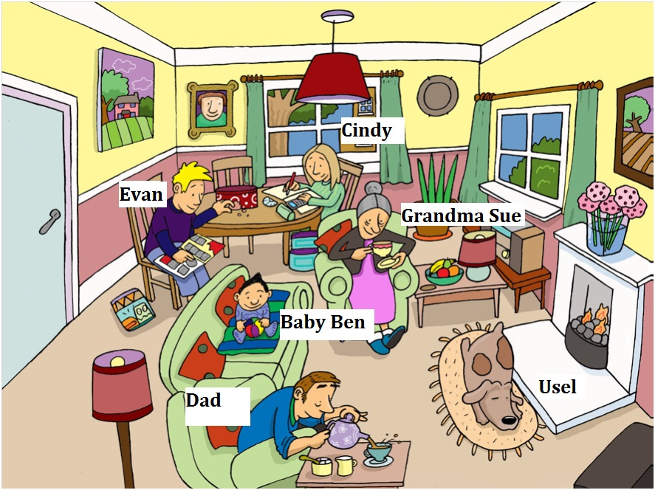
- ____Grandma Sue is drinkinking tea_______________________________________.
- ____There is a fireplace in the room_______________________________________.
- ____Dad is drinking tea/coffee.___________________________________________.
- ____There is a dog in front of the fireplace__________________________________.
- ____Evan is reading a book______________________________________________.
- ____The dog, Usel is sleeping_____________________________________________.
- ____Baby Ben is playing with a ball________________________________________.
- ____There are some pictures on the wall____________________________________.
- ____Cindy is doing her homework_________________________________________.
- ____Baby Ben is sitting on the sofa________________________________________.

- Put the words in order to make questions. Then write short answers about you.
- You / are / shoes / wearing ?
__Are you wearing shoes ? Yes, I am / No, I’m not__.
- Your / is / ringing / phone ?
Is your phone ringing? (students’ own answers)
- Are / pen / a / with / exercise / this / doing / you ?
Are you doing this exercise with a pen?
- Room / other / the / sitting / are / people / in ?
Are people sitting in the other room?
- Music / is / room / the / in / playing ?
Is music playing in the room?
- Exercise / enjoying / are / this / you ?
Are you enjoying this exercise?
- Teacher / is / your / writing / the / board / on ?
Is your teacher writing on the board?
- Your / drinking / classmates / coffee / are ?
Are your classmates drinking coffee?

- Complete the dialogue with the verbs in the box in Present Continuous.
look at | take | ski | listen to | sit | wear | read | do | make | snow

Ann: I’ve got some new photos here.
Ben: Great!
Ann: This is our school excursion to the museum. I am looking at some ancient objects. And this is our teacher. She is reading a guidebook about the museum.
Ben: Who are the people near your teacher?
Ann: I don’t know.I think they’re tourists – they are taking photos. And this is my party.
Ben: What are Karen doing in this photo?
Ann: She’s dancing to heavy metal music!
Ben: She’s crazy! And are you wearing a hat in this photo?
Ann: Yes, I am! I like my hat!
Ben: Where are you sitting in this photo?
Ann: In my garden. We are listening to music. Look at my mum here. She is making lunch.
Ben: And who’s this? I can’t see very well. It is snowing and very cold.
Ann: That’s you! You are skiing in the mountains.

- Put the verbs in the correct form, Present Simple or Present Continuous.
- Let’s go out. It is not raining (not/rain) now.
- Julia is good at languages. She speaks (speak) four languages very well.
- Hurry up! Everybody is waiting (wait) for you.
- ‘Are you listening (you/listen) to the radio?’ ‘No, you can turn it off.’
- ‘Do you listen (you/listen) to the radio every day?’ ‘No, just occasionaly.’
- The River Nile flows (flow) into the Mediterranean.
- Look at the river. It is flowing (flow) very fast today – much faster than usual.

- Complete the postcard using the present simple or the present continuous form of the verbs.
Dear Maria,
We are having (have) a fantastic time here in New York! It is (be) quite cold but that’s OK. Every morning we get up (get up) quite late and we have (have) breakfast in a diner. The breakfasts here are great – lots of food and good coffee! In the afternoon we usually visit (visit) one of the sights or we sit (sit) in Central Park and we write (write) our postcards. It’s sunny today, so we are having (have) lunch outside. We are (be) really relaxed!
Can’t wait to see you soon,
Francesca and Matteo

VOCABULARY
- Complete the sentences with the verbs below. There are two extra words.
order | look for | pay for | spend…on | shop | try on

- After work I go to a mall for window shopping. I don’t ___look for__ anything special. You know, just to relax.
- A: Can I help you?
B: Yes, please. I’d like to ___try on__ that jacket .
- How would you like to ___pay for___ these shoes?
- I don’t __spend__ a lot of money ___on__ clothes.

KEY LANGUAGE
- Complete the discussion in a business studies class between some students and the teacher. Use the words in the box. There is one extra word.
COMPUTER | PAY FOR | ONLINE SHOPPING | PRODUCTS | TRY ON | MAIN
ORDER | SECOND | CHANGE | DISADVANTAGES | ANOTHER | CHECK

T: A lot of people think traditional shopping is dying. Well, online shopping has a lot of advantages, but does it have any disadvantages?
S1: Yes, it does. I think there are two main disadvantages. The first is that you can’t see the real products. This means that you can’t try on clothes or check that food is good, for example.
T: Right. What’s the second disadvantage?
S1: Well, it is that you order a product online and then you wait for a few days – or weeks. In a shop, you can get it right there.
T: Good. What other advantages does traditional shopping have?
S2: One important advantage is that a lot of people enjoy it . I don’t think online shopping can change that.
S3: Yes, and another advantage is that it’s good for you. I mean it’s healthier than sitting at a computer.
T: OK. Are there any more advantages?

